**Project Title: WATER QUALITY ANALYSIS**

**Objective:** To develop a cutting-edge water quality analysis system that combines IoT sensors, AI technology, and real-time data analysis for more precise water quality assessment.

IoT in Water quality analysis:

Undoubtedly, water is the most essential resource on our planet. Without it, life will cease to exist and will definitely collapse within a few days. Not only for general usage, but its application in industries also helps in the creation and refining of other resources and products that are essential for our existence and sustainable living.

However, we have been exploiting this irreplaceable resource for decades. Out of the 71% water that covers the Earth’s crust, only 2.5% or even less is suitable for drinking. This has resulted in severe consequences in terms of increased concentration of pollutants in freshwater bodies along with water scarcity in different corners of the globe.

**Challenges associated with Manual Water Quality Monitoring Method**

Manual methods of water quality measurement along with being time-consuming and cost-intensive also pose the following challenges:

**• Errors** and mistakes are the general nature of human beings. Hence, errors are prone to be made when water quality readings are taken manually.

**• Data Quality** definitely decreases if the readings are inaccurate or flawed. Moreover, developing useful insights from this data also takes a considerable amount of time.

**• Efficiency** and cost-effectiveness of taking manual water quality readings is quite low as it consumes a lot of time and effort.

**• Training** and proper education is required to be given to the workforce and prepare them to take on-site readings.

**• Manual Inspection** of probes and sensors also waste a lot of productive time that could have been utilized for efficient reading procedures.

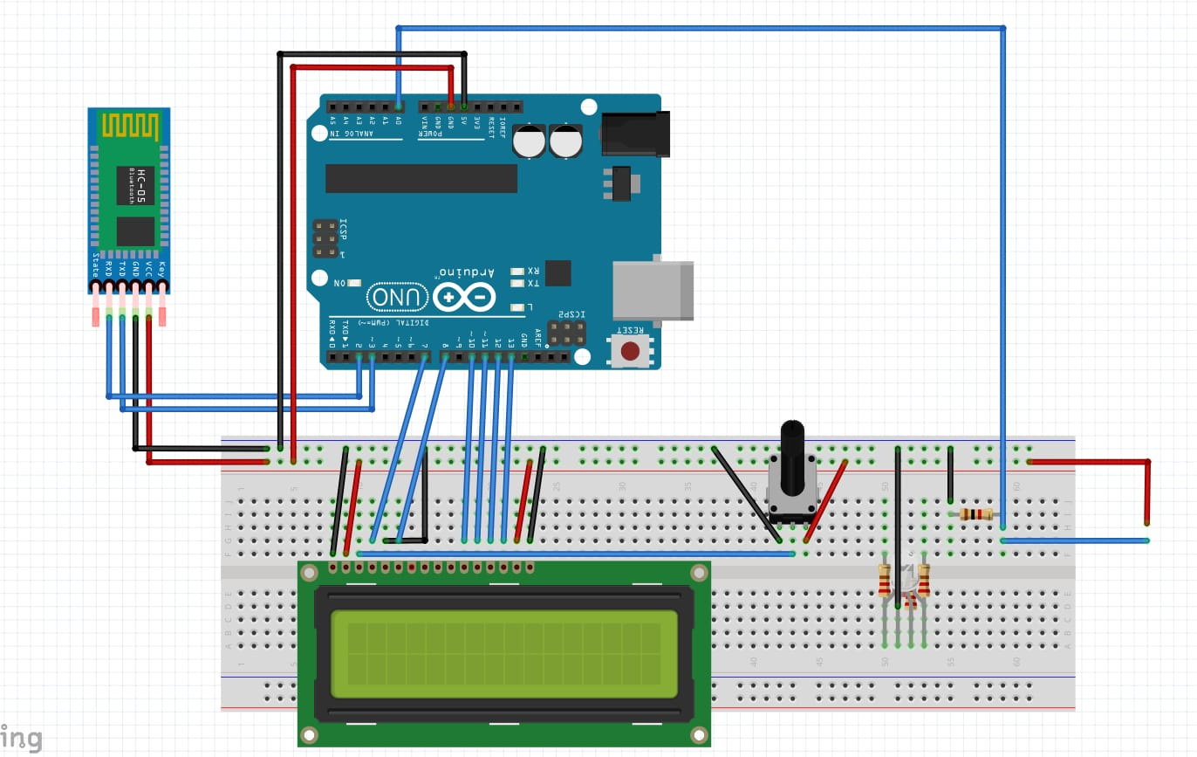

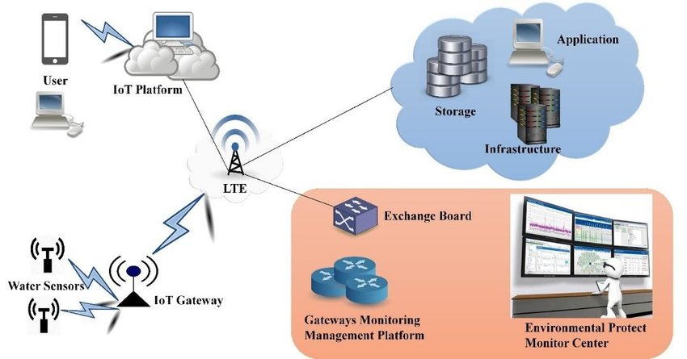

**Real-time Data Collection:** Use these sensors to collect data continuously and transmit it to a central database or cloud server in real-time. This ensures up-to-the-minute information on water quality.

Real-time data collection for water quality analysis is essential for monitoring and responding to changes in water quality promptly. To implement real-time data collection, you'll need the following components and steps:

1. **Sensors and Probes:** Select appropriate sensors and probes for measuring the specific parameters you want to monitor, such as pH, turbidity, dissolved oxygen, temperature, and chemical contaminants. These sensors should be capable of providing continuous data.
2. **Data Loggers:** Connect the sensors to data loggers or datalogging systems. Data loggers collect data from the sensors and store it for further analysis. Many data loggers can transmit data to a central server or cloud platform in real-time.
3. **Connectivity:** Ensure a reliable and stable internet or cellular connection at the monitoring sites. This connectivity is crucial for transmitting data to a central database or cloud server.
4. **Central Database or Cloud Platform:** Set up a central database or use a cloud-based platform to store the incoming data. Cloud platforms are often preferred for their scalability and accessibility.
5. **Data Transmission:** Configure the sensors and data loggers to send data to the central database or cloud platform at regular intervals. This can be done via wired or wireless communication, depending on the availability of infrastructure.
6. **Data Validation and Calibration:** Regularly calibrate and validate the sensors to ensure the accuracy of the data. This step is critical for reliable water quality analysis.
7. **Real-Time Data Visualization:** Create a user-friendly interface or dashboard to visualize the data in real-time. Users, such as environmental managers or researchers, should be able to access this interface to monitor water quality continuously.
8. **Alert System:** Implement an alert system that can notify relevant personnel when the data indicates a significant change or deviation from established thresholds. Alerts can be sent through email, SMS, or other communication methods.

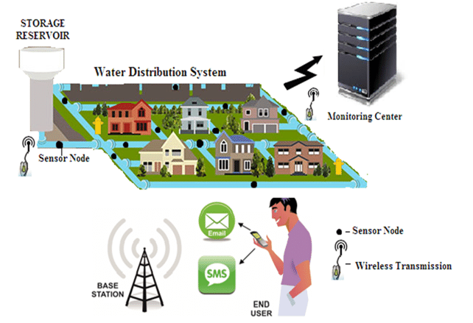

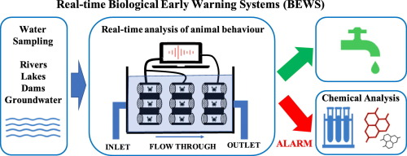

**Water quality prediction using machine learning methods**

Water quality has a direct impact on public health and the environment. Water is used for various practices, such as drinking, agriculture, and industry. Recently, development of water sports and entertainment has greatly helped to attract tourists (Jennings 2007). Among various sources of water supply, due to easy access, rivers have been used more frequently for the development of human societies. Using other water resources such as groundwater and seawater sometimes assisted with problems.

## MATERIAL AND METHODS

The aim of this study is the prediction of water quality components using artificial intelligence (AI) techniques including MLP, SVM, and group method of data handling (GMDH). Therefore, in the first part of this section, the studied area is introduced and then ranges of measured water quality components are presented. Overviews on applied AI models are then presented.

Table 1

Summary of values of measured water quality parameters by RWA

| **Parameters** | **Min** | **Max** | **Mean** | **Variance** |
| --- | --- | --- | --- | --- |
| Q (m3/s) | 0.3 | 1,000.00 | 10.56 | 70.64 |
| T.D.S (mg/L) | 17.00 | 894.00 | 288.04 | 119.48 |
| EC (μmohs/cm) | 30.00 | 1,355.00 | 448.17 | 182.28 |
| pH | 6.20 | 8.85 | 7.80 | 0.41 |
| HCO3 (mg/L) | 0.35 | 7.70 | 3.29 | 0.99 |
| Cl (mg/L) | 0.02 | 7.70 | 0.75 | 0.83 |
| SO4 (mg/L) | 0.00 | 4.65 | 0.42 | 0.40 |
| Ca (mg/L) | 0.50 | 5.60 | 2.63 | 0.81 |
| Mg (mg/L) | 0.04 | 5.40 | 1.25 | 0.71 |
| Na (mg/L) | 0.01 | 4.00 | 0.58 | 0.67 |
| SAR (mg/L) | 0.01 | 3.02 | 0.40 | 0.43 |

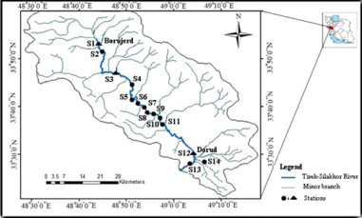

Artificial neural network (ANN)

The initial development of the ANN used a data mining approach taken from the human brain's nervous system. This means that the structure of ANN consists of networks of neurons that work together in parallel ([Zahiri et al. 2015](javascript:;)). Mathematical operations of neurons are provided in [Figure 2](javascript:;). As shown in this figure, inputs are multiplied by a series of weights and then summed by a constant value. Then a transfer function acts on the results of the previous computation. The mathematical expression of neuron computation is given in Equation ([1](javascript:;)):

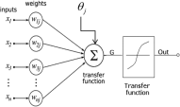

**Data Visualization:** Create a user-friendly interface or dashboard that displays the data in an understandable and visually appealing manner. This allows stakeholders to monitor water quality easily.

Data visualization uses various techniques and tools to represent data graphically in a way that is easy to understand, interpret, and derive insights from. Some of the common elements and techniques used in data visualization include:

1. **Charts and Graphs:** Charts and graphs are fundamental tools in data visualization. They include bar charts, line charts, scatter plots, pie charts, area charts, and more. Each type of chart is suited to visualizing specific types of data and relationships.
2. **Tables:** Tables are often used to display structured data, especially when precise numbers and comparisons are required. They can be enhanced with color-coding and formatting for better clarity.

**Alert System:** Implement an alert system that can automatically notify relevant authorities or personnel when the AI detects a significant deviation from the normal water quality parameters. This enables quick response to potential issues.

Alert systems used in water quality analysis are designed to provide timely notifications when certain conditions or parameters related to water quality deviate from established thresholds or standards. These systems play a crucial role in ensuring the safety of water resources, human health, and the environment. Here's an elaboration on the types of alert systems commonly used in water quality analysis:

1. **Threshold-Based Alert Systems:**
   * **Parameter Threshold Alerts:** In these systems, predefined thresholds are set for specific water quality parameters (e.g., pH, turbidity, dissolved oxygen). When the measured values cross these thresholds, the system triggers an alert. For instance, if the pH level falls below a safe threshold, indicating increased acidity, an alert is generated.
   * **Compliance Alerts:** These alert systems are used to monitor compliance with water quality regulations and standards. If water quality parameters violate legal limits (e.g., safe levels for drinking water contaminants), regulatory agencies and responsible authorities are alerted for prompt action.

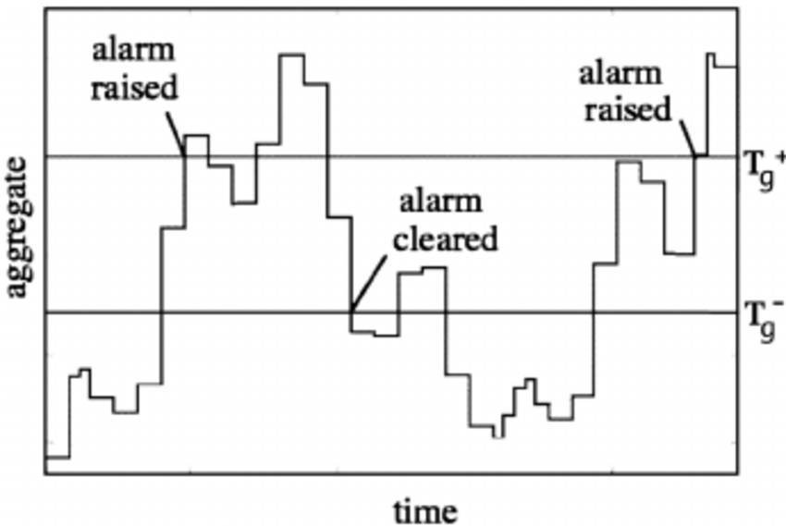

1. **Anomaly Detection Alert Systems:**
   * **Statistical Anomaly Detection:** These systems employ statistical techniques to detect anomalies or unusual patterns in water quality data. Any significant deviation from the expected norm, even if within legal limits, triggers an alert. This can help identify trends or incidents that require investigation.
   * **Machine Learning-Based Anomaly Detection:** More advanced systems use machine learning algorithms to identify anomalies in the data. These algorithms learn from historical data patterns and can adapt to changing conditions, making them effective at identifying subtle variations or emerging issues.
   * 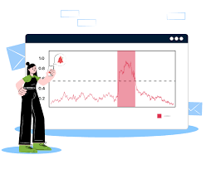
2. **Predictive Alert Systems:**
   * **Predictive Modeling:** Some alert systems use predictive models to forecast water quality changes. By analyzing historical data and considering factors like weather, season, and pollution sources, these models can predict potential water quality issues before they occur. For example, predicting algal blooms based on temperature and nutrient levels in a water body.
   * **Early Warning Systems:** These systems are designed to provide early warnings for natural disasters (e.g., floods, hurricanes) or industrial accidents that may impact water quality. They use real-time weather and environmental data to predict and mitigate potential water quality crises.

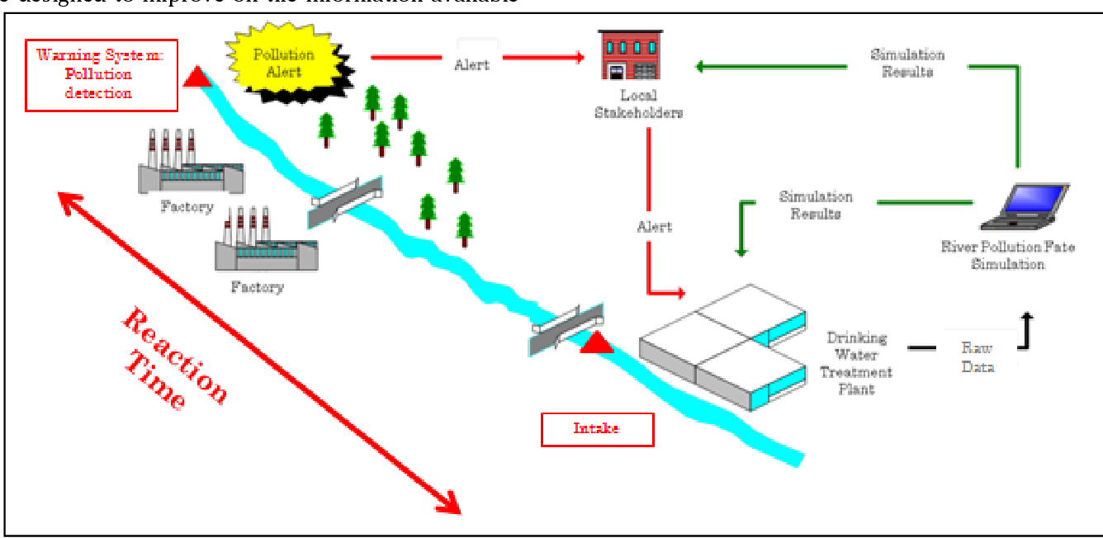

**Conclusion:**

In a world where the quality of our water resources is paramount for both environmental sustainability and public well-being, the development and implementation of real-time data collection systems for water quality analysis are critical innovations. This project represents a significant leap forward in our ability to monitor, understand, and respond to changes in water quality with unprecedented accuracy and speed.

Through the integration of advanced sensors, data loggers, and cloud-based technologies, this project has created a robust and dynamic system that continuously collects, analyzes, and visualizes water quality data. By providing real-time insights, it empowers environmental managers, researchers, and relevant authorities to make informed decisions and respond promptly to deviations from established standards.

The incorporation of an alert system further enhances the project's value by enabling immediate responses to potential issues, safeguarding not only the environment but also the health of communities that rely on these water sources. This proactive approach to water quality management is essential in preventing contamination events and minimizing their impacts.

Moreover, the use of machine learning and data analysis tools adds a layer of intelligence to the system, allowing it to identify patterns and anomalies that might otherwise go unnoticed. This predictive capability not only helps in understanding past events but also offers a glimpse into the future, enabling early intervention to protect water resources.

The user-friendly interface and data visualization tools ensure that the collected data is not only precise but also accessible and understandable to a wide range of stakeholders. This fosters public awareness, engagement, and participation in the protection and conservation of our water resources.

In conclusion, the "Smart Water Quality Monitoring System with AI Analysis" project serves as a beacon of innovation and progress in the field of environmental science and technology. By harnessing the power of real-time data collection and analysis, this project contributes to the preservation of water quality, promoting a sustainable and healthier environment for current and future generations. It is a testament to the power of technology and human ingenuity in addressing the challenges of our time.